## horizontal line

SW Engineering CSC 648/848 Summer 2022

YourSport

Team 2

**─**

Team & BackEnd Lead

Kshitiz Sareen: [ksareen@sfsu.edu](mailto:ksareen@sfsu.edu)

Frontend

Lead Kevin Islas

Developer Shamar Ireland

Functional

Lead Sabur Saigani

Assistant Jonathan Ip

Database Administrator

Wenye Guo

Github Master

Mathew O Abiola

**Milestone 1**

# Executive Summary

The product that we are trying to build is called YourSports. Today, many sports applications are focused on providing news and real-time updates to live games, however, most of these products do focus on the information that a particular user is looking for, but instead provide information as a whole, leaving the user to scrap through all the data, to find any information that is relevant to their interests. This leaves the user unsatisfied, hence they stop using these products. Our product is a one-stop solution for all the sports fans, as our application focuses on personalizing information for the users, by providing data that is focused on their favorite teams and players.

YourSports is a web application that offers countless services to its customers, from real-time trends to fantasy betting, that will keep users engaged and updated with real-time information. Our product will allow users to access live Twitter feeds that relate to their favorite teams and players, provide information on any games that they would like to watch, allow users to easily access player statistics, provide real-time updates of live games, and have group chats where users can interact with fans of similar interests. Our product will also keep users engaged through fantasy betting. The sports industry involves a lot of betting, where fans have lost enormous amounts of money. Our product will allow fans to bet with the same amount of energy, and also not waste any money through fantasy betting. Instead of betting with money, users can bet through points, and they will win or lose according to the outcome of the games they have betted on. These points can be used to win prizes. This is one of our application’s unique services that will help users by disrupting the betting industry.

Our product is designed to covers wider aspects of contents without overflowing users with unnecessary information, and we believes that will attracts more consumers who were once disappointed to find their satisfaction within YourSport. And since it is very interactive, it can generate revenue by providing enormous amounts of data to different companies, that can use this data to advertise their products on our platform.This application can also be expanded to a talent acquisition company, that will help new and talented players, enter the industry. Our product is the solution to all the problems that existing products in the sports industry face, and it has a lot of potential for growth.

# Use Cases

## Actors

Steward (Student):

Characteristics, skills, and pain points:

* Likes to keep track of sports
* Very busy with his studies
* Very impatient
* Very straightforward
* Gets irritated easily
* He does not like browsing through many websites to be updated with sports news.

Goals:

* He wants to be updated with sports news without browsing multiple websites.
* He would only like news that caters to sports

Mathew (Gambler):

Characteristics, skills, and pain points:

* He loves to take risks
* He loves to travel a lot
* He is addicted to gambling
* He has lost a lot of money from gambling

Goals:

* He wants real-time updates on the bets he places while traveling so that he is not anxious about whether he has won or lost money
* He wants to continue gambling, without losing actual money
* He wants a platform that can help him practice betting with virtual money, instead of real money, so that he is better prepared when placing bets with real money.

Wendy (Cashier):

Characteristics, skills, and pain points:

* Wendy has a child who she needs to take care of.
* She is a big fan of the warriors.
* She is very busy with her family.
* She cannot watch games due to time constraints.

Goals:

* She wants real-time updates of games in which the lakers play through text broadcast and commentary as she cannot watch live games.
* She also wants notifications instead of checking through multiple platforms for information.
* She would also like to be involved in the game by sharing her opinion on live games.

John (Engineer):

Characteristics, skills, and pain points:

* John has no interest in sports.
* John’s friends are interested in sports, and he feels left out because he cannot have a conversation with them when they talk about sports.
* He is very social.
* He likes to make new friends.
* He is very busy with his work

Goals:

* He wants easy access to sports information so that he can learn more about sports.
* He wants to make new friends who are into sports and have conversations with them.
* He wants to follow basketball and he does not want to watch live games, however, he wants notifications of any updates in a game.

Jane :

Characteristics, skills, and pain points:

* Jane is a big fan of basketball.
* She is a big fan of the Lakers.
* She is a big fan of Lebron James.
* She has no interest in reading news that is not related to Lakers or Lebron James.
* She gets distracted easily.
* She uses Twitter a lot.

Goals:

* She wants news that is only related to Lakers or Lebron James.
* She does not want to miss any tweets related to Lebron James or the Lakers.
* She does not want to open Twitter because she gets distracted by tweets from other users and topics.
* She also wants updated stats of the players in a season.

Maxey (Student):

Characteristics, skills, and pain points:

* Maxey loves basketball.
* Maxey loves going out with his friends to watch basketball games.
* He is really busy with studies and work.
* He works in low-income jobs and cannot afford to watch games that fit his budget.
* He is impatient.
* He does not like checking through multiple websites to find nearby games, where his favorite teams are playing, and they fit his budget.

Goals:

* He wants information on games that are not far away, have his favorite teams playing, and fit his budget.
* He wants notifications of any games that fit his criteria.
* He wants real-time updates of any games through text, that he is not able to attend.

Julia (Sports Journalist):

Characteristics, skills, and pain points:

* Julia creates news articles about sports.
* She creates articles that cater to users of specific interests.
* She does not like publishing her articles on every sports website.
* Her articles don’t get many views because they are not able to users that the article is intended for.

Goals:

* She wants to publish her articles on websites that cater to the specific interests of users.
* She wants her articles to be read by users who have the same interest in the information presented in her article

## Cases

Signing up

Actors: Steward

Steward makes a Google search on latest sports news. The third search result shows him the YourSports website. He opens the website and scrolls through the homepage. The homepage has all the latest news and it shows a lot of features like searching games, and fantasy betting. He clicks on fantasy betting however it states that he must be signed up to use this feature. He is intrigued by fantasy betting and he wants to sign up.

He clicks the sign up option, where he is prompted to fill in details like first name, last name, username, email, password and date of birth. He fills in all the details and clicks sign up. An error message is popped up stating that a user with the same username already exists. He changes the username and tries to sign up again. It fails again because he has not yet agreed to the terms of service. After agreeing to the terms of service, he tries again and this time the sign up is successful.

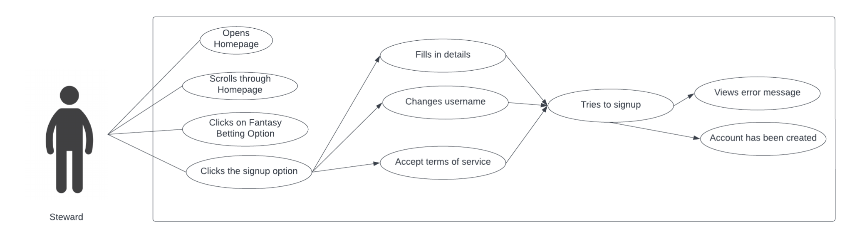

Logging In

Actors: John

John wants to follow the game of Warriors vs Celtics. Unfortunately, he is traveling and he has no one to watch the game with. He does not want to watch the game alone. He opens the YourSports website to follow the game. He sees a group chat that is following the game and he tries to open the group chat.

He is prompted with a message, saying that he needs to log in to access the group chat. He already has an account, so he clicks the log in button. He fills in the email and password, and logs in to send messages in the group chat.

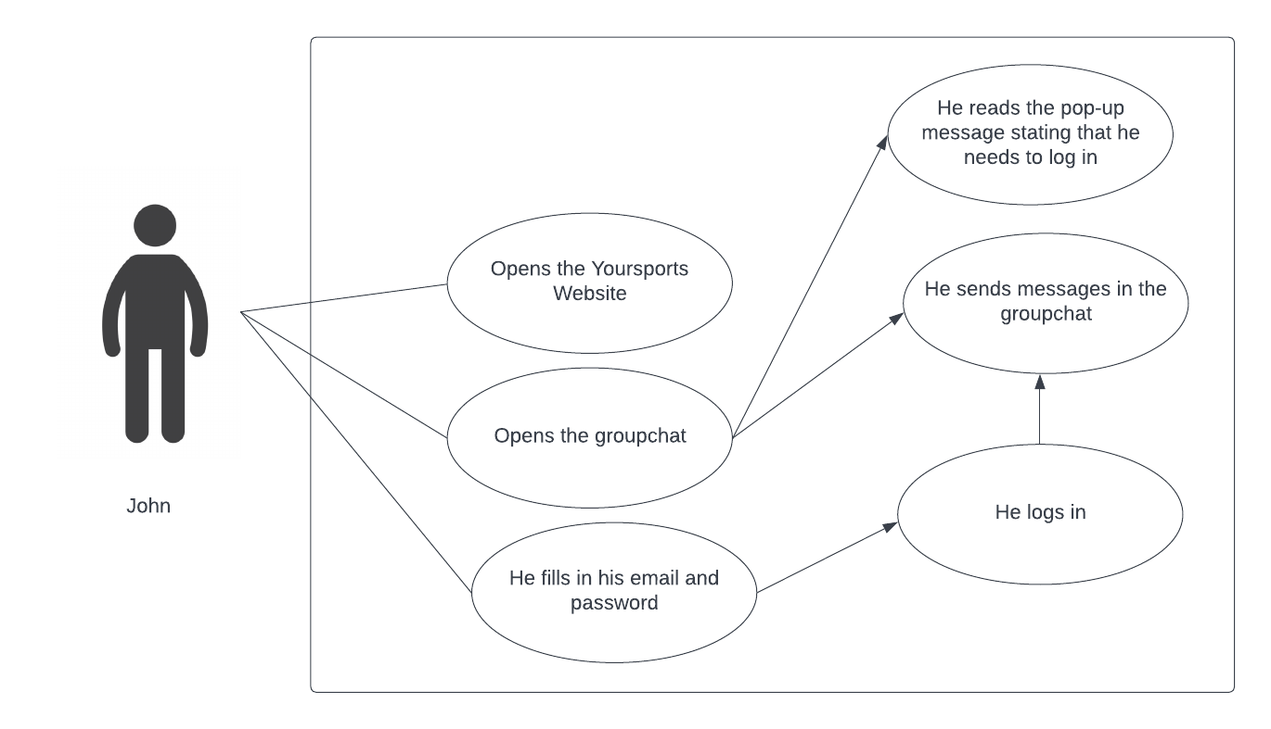

Checking Sports news

Actors: Steward

Steward likes to keep track of sports. His favorite sport is basketball. He has subscribed to many sports websites and mobile apps that send him updates on sports news via email and notifications. He gets distracted very easily from the notifications and he does not read most of the news he receives as they give him information on all sports, but he only reads the news that is related to basketball.

He opens the YourSports website. He opens the account settings . He chooses his news to only be related to basketball. He also sets his preferences of receiving emails on sports news only once a day. Steward now only receives an email once a day from YourSports that consists of news that is related to basketball.

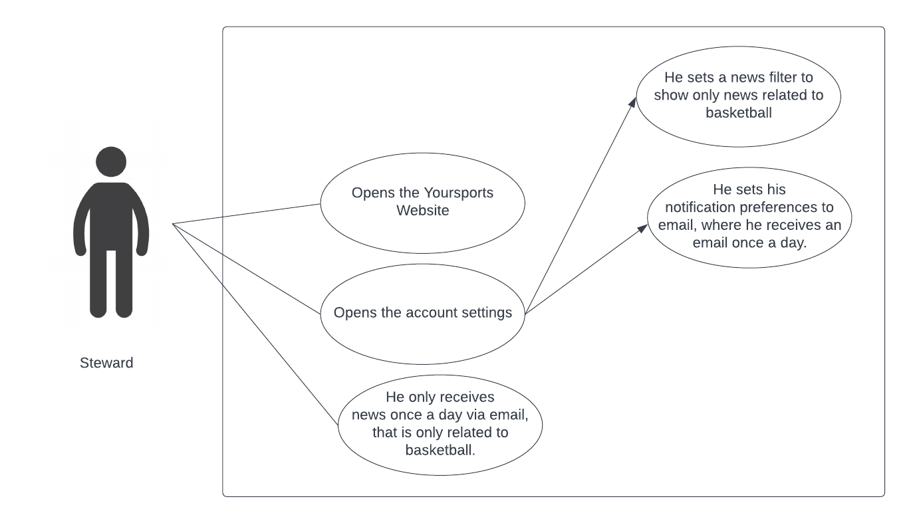

Checking Twitter Feeds

Actors: Jane

Jane is a big fan of Lebron James and the Lakers, and she regularly tweets about them. She does not want to miss a single tweet about them, but she does not want to open twitter to avoid distraction.

She opens the YourSports website to see live Twitter feeds on sports. She wants to only see twitter feeds related to Lebron James and the Lakers. She chooses her target topics as Lebron James and the Lakers. She also enables the option for receiving emails from YourSports regarding any new tweets that are related to the topics she follows.

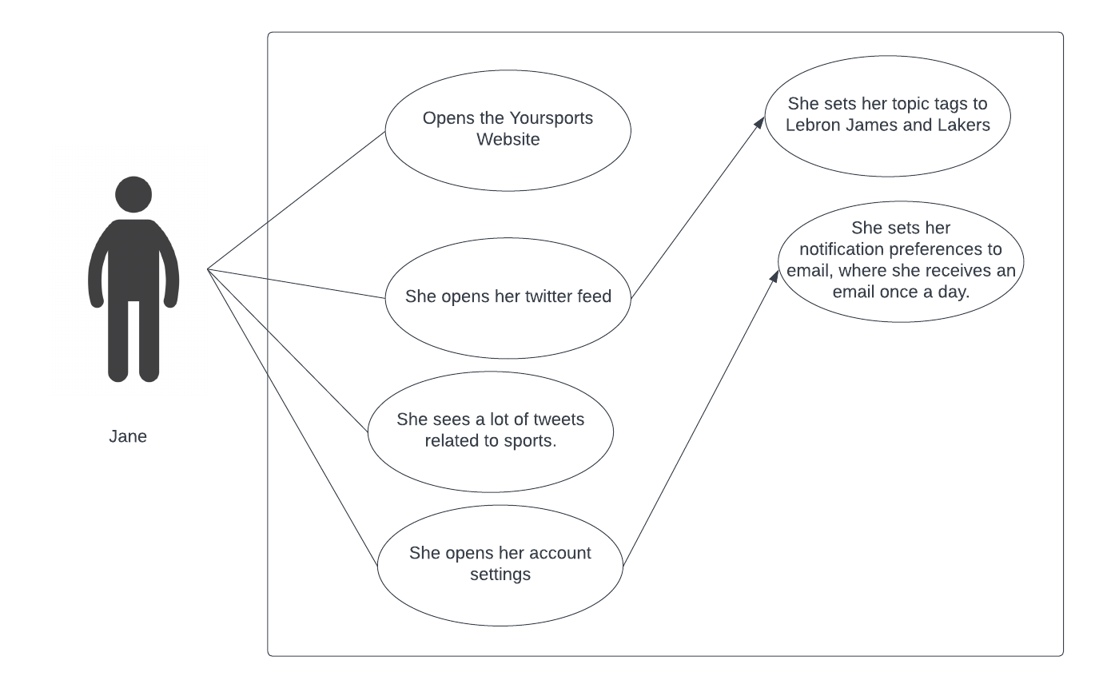

Fantasy Betting

Actors: Mathew

Mathew is very addicted to gambling and sports betting. He has lost a lot of games previously and is in a lot of debt. He is trying to find a platform where he can practice sports betting without using real money.

His friend tells him about YourSports where he can bet on any live and upcoming games, with YourSports coins instead of real money. He decides to bet on the game of the Warrios vs Celtics. He sees the player statistics of Steph Curry and Jayson Tatum. He sees that Steph Curry has a better performance, and therefore Warriors have a higher chance of winning. The updated statistics of Steph Curry helped Mathew make a more calculated decision on who to bet on. His decision was fruitful as Warriors won the tournament. He realized he enjoyed fantasy betting as much as betting with real money, and he does not wish to bet with real money anymore.

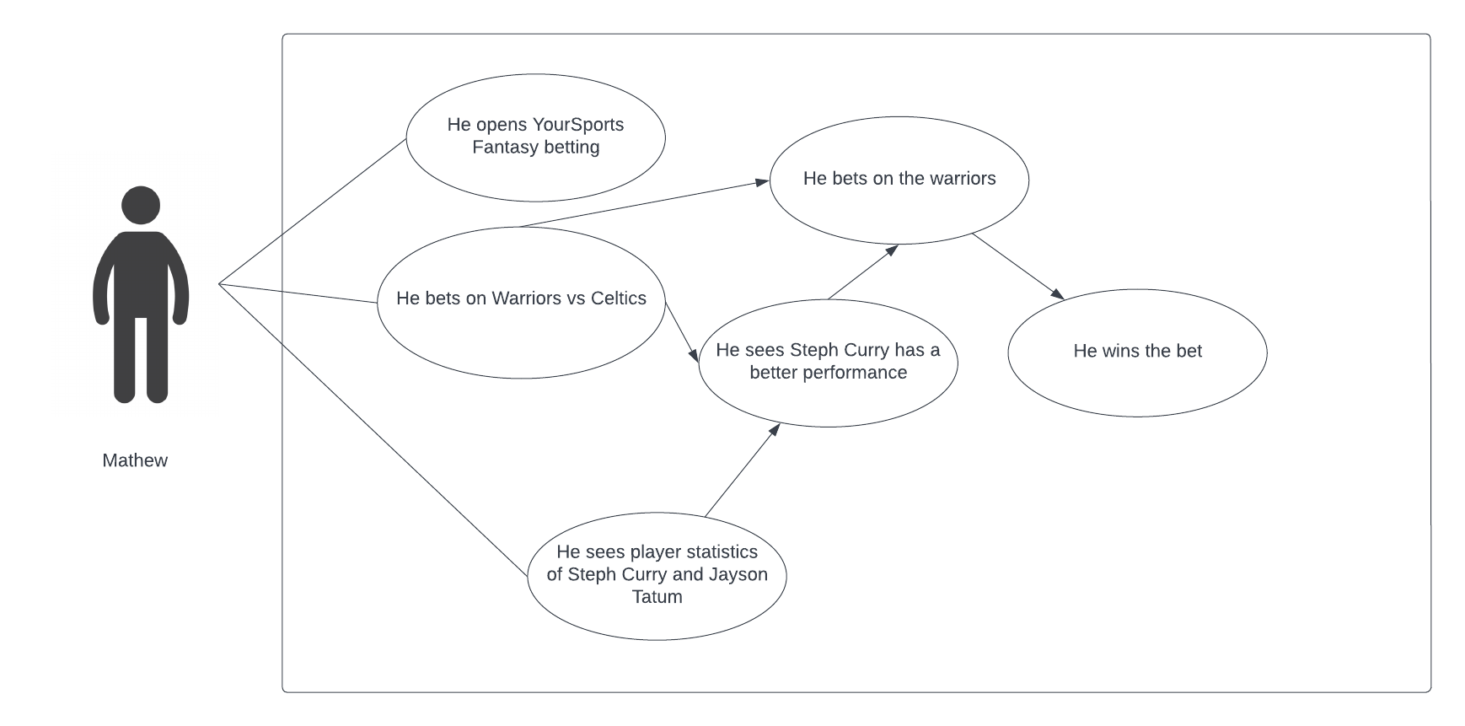

Following sports games

Actors: Wendy

Wendy is very busy with her work and she also has a child to take care of. Due to her busy schedule, she cannot watch the games of the Warriors vs Celtics. She cannot watch the videos and would like to read text commentary about the game. She opens YourSports website, and chooses to follow the Warriors vs Celtics game, and set receiving notifications via sms on her phone, for any update in the game. From time to time, she also opens the YourSports website and post her views on the current game in the discussions forum of the game.

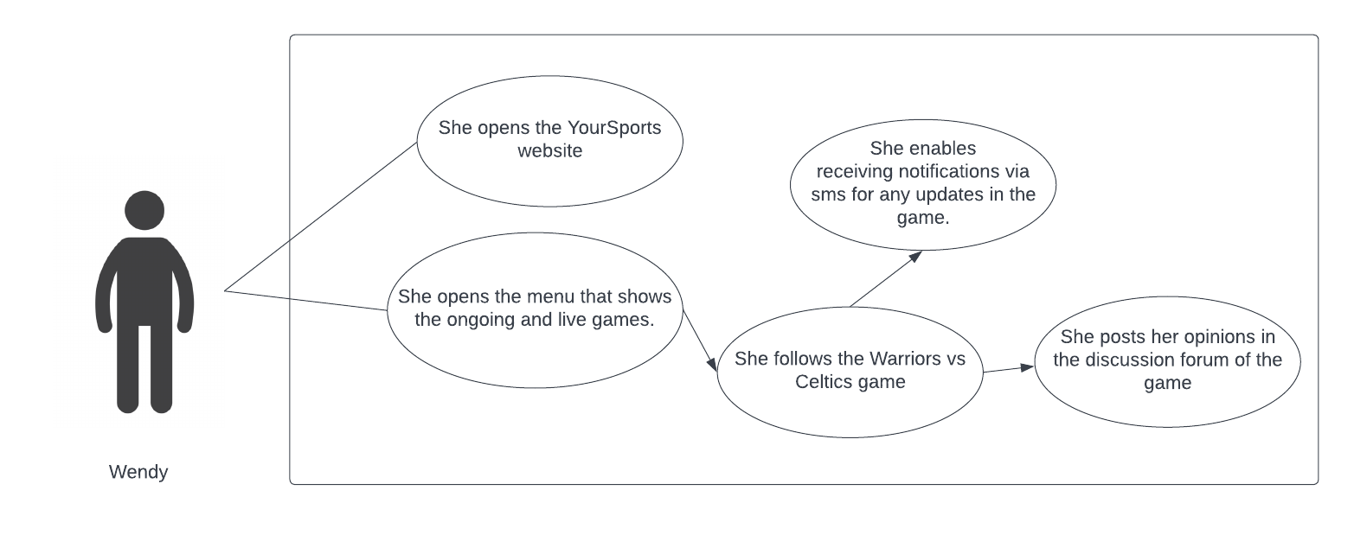

# Competitive Analysis

| Feature | Yahoo! Sports | Thescore | Flashscore | ESPN Sport | BBC Sport |
| --- | --- | --- | --- | --- | --- |
| Strengths | Have a good and wide range of sports news, site’s visual presentation is precise and attractive.  Navigation bar have most sports tyoes as individual tabs and will extend into more detailed catagories when the cursor hovers on it.  Scoreboards located right below the Nav-bar, and the most attractive news and informations are enlarged and grouped on the top of the site.  Also changes quick access teams according to you location data. | News available on a variety of sports,  Easy to use,  Easy to access information on latest games | live scores and lineup updated in real time  based on different categories  live commentary by text  detailed statistics  odds comparison  Less ads | One bus stop for multiple news platform including SEC network,  Access to ESPN insider,  Live update of different sports on home page  Video highlights of random sport games  Cable channels  Search bar  Can stream games | Has lots of news and blog post about different sports  It also uses social media to advertise its app. |
| Weaknesses | Advertisement is everywhere and distracting.  Too many news that does not directly related to the sports or players like comment of some politians and celebrities.  The site advertise their own betting system but with very technical terms which makes it hard to understand. | No personalization for users,  A lot of advertisements on the website,  Bad user interface,  No Subscription feature | Favorite team limit 100  Small available date range  Some sports updates are not accurate | False advertisement of service  Bias commentary, one sided coverage  Hard to navigate and glitches  Poor service review by users | Is not organized  Some of the news and blog post are not updated  Has lots of adds |
| Pricing | Generally free, can add money to fantasy betting through Paypal | No subscription fees,  All revenue generated is from advertisements | Free, bet using one of advertised sportsbook partners | Free for guest/unregistered users | No Subscription/Free |
| Social Media | Facebook, Twitter | Facebook, Twitter, Instagram | Facebook, Twitter, Instagram | Facebook, snapchat, twitter, instagram, | Twitter, Facebook, Instagram, Youtube |
| Onboarding Experience | Most informations onsite is very straight forward.  Just have to follow the names on the navigation bar and you will be able to find informations that you are looking for.  However, there will be informations that maybe too technical for newcomers to understand.  There is also no tutorial for the fantasy betting system, and the betting system is very confusing without any explanation. | No support from the website,  A moderate number of steps are required to understand the website. | Easy to find info  Seamless onboarding | Overwhelming with multiple random sports updates, highlights.  Not easy to navigate | Doesn't help you with your first step  Really hard not navigate  Takes a while to get use to |

| Feature | Yahoo! Sports | Thescore | Flashscore | ESPN sport | BBC Sports | YourSport |
| --- | --- | --- | --- | --- | --- | --- |
| Access to Live Twitter Feeds | + | - | - | - | - | + |
| Search by filter for news articles | ++ | - | - | + | + | + |
| Group Chats | - | - | - | - | - | + |
| Text Commentary | - | + | + | + | ++ | ++ |
| Access to Player Statistics | + | - | ++ | ++ | - | + |
| Fantasy Betting | + | - | + | ++ | + | + |

Does not exist: - Exist: + Superior: ++

# Technology Specifications

Server Host

Google App Engine

Memory Limit

256 MB

CPU Limit

600 MHz Automatic Scaling

Operating System

macOS Monterey 12.4

Database Management

MySQL 8.0

Server Environment

Node.js 14.0.0

BackEnd Framework

express 4.18.1 (JavaScript)

FrontEnd Framework

React

IDE

Visual Studio Code

Web Analytics

Google Analytics

# Checklist

## TBD

Details

## TBD

Details